**Body**

Total grid size is 12

Left part - Main page is of size gird 8

Right part -Sidebar is of size grid 4

We will create this

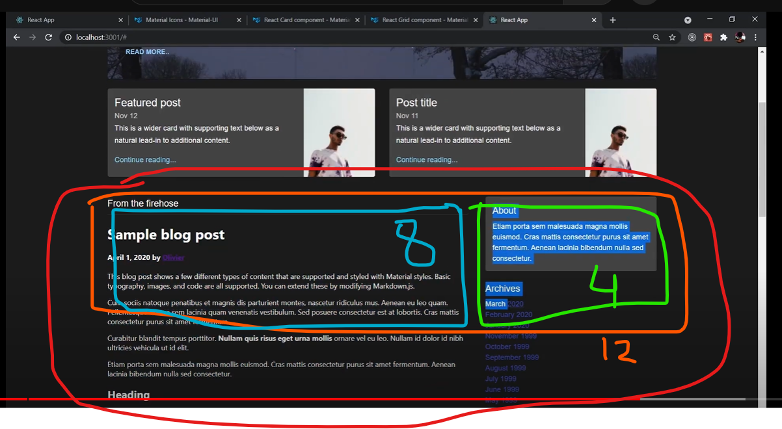

===============================Code======================================